**Week 5:  Ethical Hacking Fundamentals**

**Objective:**  Perform safe, simulated penetration tests.

**Task#02: Perform a simulated DoS attack (Ping of Death) on your local VM (safely within virtual environment).**

**Solution:**

**DOS attack using HULK:**

**Attack Start (Note the CPU%):**

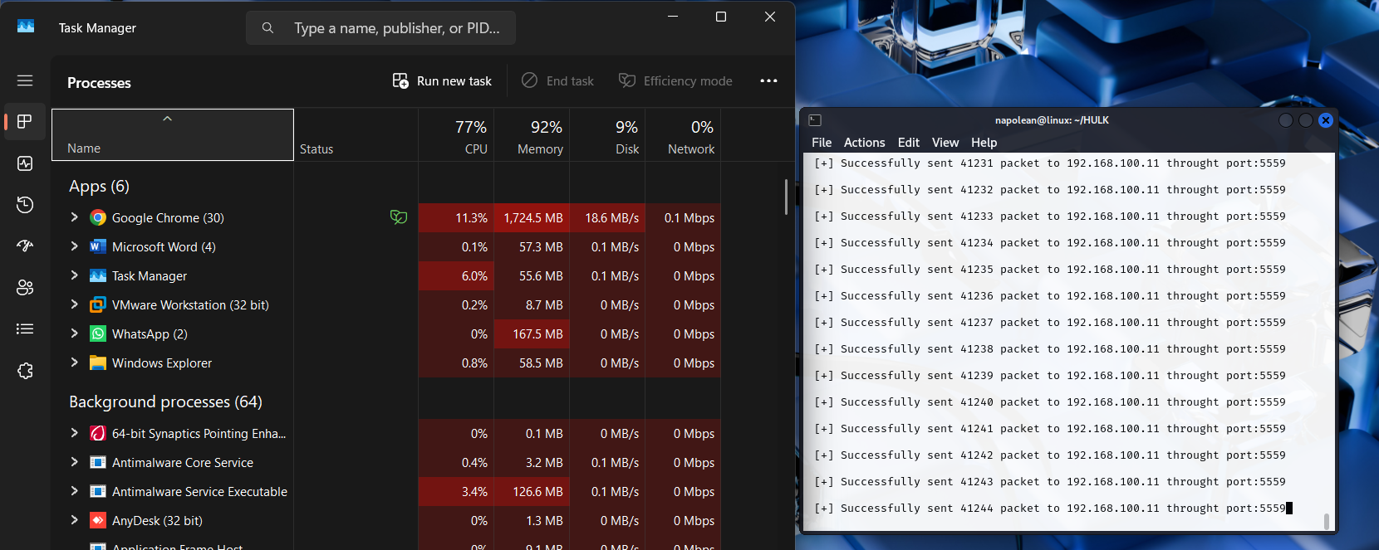

**Attack Stop (Note the difference):**

